What is web server?

- A Web server is a program that uses HTTP to serve the files that form Web pages to users.

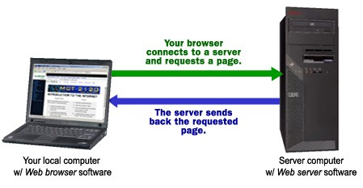

Two main types
1. Apache --- open source and free
2. NGNIX ------ Not open source but process the cleint request asynchronously.

- Support, bug fixes, and application development in Apache HTTP server is managed and maintained by a community of users and coordinated by the Apache Software Foundation. Support and maintenance of Nginx is handled by a company of the same name which was founded in 2011.

- The major difference between the two is the way both handle client requests.

- Apache provides a variety of multiprocessing modules to handle client requests and web traffic, Nginx is so designed to handle multiple client requests simultaneously
- In Apache HTTP server, single thread is associated with only one connection.
- single thread in Nginx can handle multiple connections. All the processes are put in an event loop along with other connections and are managed asynchronously. This process consumes less memory thereby increasing performance.
- Apache has a multi-threaded architecture .
- Nginx, on the other hand, follows an asynchronous event-driven approach to handle multiple client requests. Its event-driven architecture is so designed to facilitate better performance even under heavy traffic.

Apache | Nginx
Apache follows multi-threaded approach to process client requests. | Nginx uses an event-driven approach to serve client requests.
It handles dynamic content within the web server itself. | It cannot process dynamic content natively.
It cannot process multiple requests concurrently with heavy web traffic. | It can process multiple client requests concurrently and efficiently with limited hardware resources.
Modules are dynamically loaded or unloaded making it more flexible. | The modules cannot be loaded dynamically. They must be compiled within the core software itself.
Apache is designed to be a web server. | Nginx is both a web server and a proxy server.
A single thread can only process one connection. | A single thread can handle multiple connections.

To check Wheather apache/NGNIX is working or not

sudo systemctl status apache2
sudo systemctl status ngnix

If not installed the we can install it by

sudo apt install apache2
sudo apt install ngnix

